Ice Measure Implementation Guide:

**A General Reference Guide for Using the "Add Ice Storage Tank" Measure in Open Studio**

**February 2020**



**Table of Contents**

1 Purpose of the Guide 1

2 Measure Overview 1

2.1 General Description 1

2.2 Measure Repository Contents 1

2.3 User Arguments 1

2.4 Model Pre-Requisites 1

2.5 Measure Limitations 1

3 Hardware Configuration Options and Implications 2

3.1 Chiller Options 2

3.2 Ice Tank Options 2

3.3 Configuration Options 2

3.4 Multiple Chillers in Parallel 3

3.5 Chiller and Loop Modifications 3

4 Implementing Control Strategies 3

4.1 Full Storage 3

4.1.1 The Full Storage Option 3

4.1.2 Full Storage via Partial Storage 3

4.2 Partial Storage 4

4.2.1 Load Leveling 4

4.2.2 Demand Limiting 4

4.3 Remarks on the Chiller Limiter 5

5 Testing Demand Response Events 5

5.1 Purpose of the DR Tester 5

5.2 Exploring Load Add Events 5

5.3 Exploring Load Shed Events 5

5.4 Example Load Shed Event 5

6 References 6

1. Purpose of the Guide

This measure is designed to provide many options to users in order to simulate the typical design configurations and control schemes for central ice storage technologies as described in the ASHRAE Cool Thermal Storage Design Guide (2019). This document provides general guidance for implementing the ASHRAE recommendations using the measure.

1. Measure Overview
   1. General Description

The measure allows users attach ice thermal energy storage (ITS) to an existing chilled water loop for the purpose of exploring load flexibility potential for a given building. Several hardware configuration and control strategy options are available to allow rapid modeling and parametric evaluation of various ITS possibilities. Schedule-based and Energy Management System (EMS) script-based controls are available at the user’s discretion. A demand-response testing script is also available to assist in evaluating the flexibility of a given ITS design and control pairing.

* 1. Measure Repository Contents

The measure folder contains the following directories and files:

* add_ice_storage_tank/
  + docs/
    - Ice Measure Implementation Guide.pdf
  + resources/
    - OsLib_Schedules.rb
  + tests/
    - output/
    - add_ice_storage_tank_test.rb
    - ice_test_model.osm
  + LICENSE.md
  + measure.rb
  + measure.xml
  + README.md
  + README.md.erb
  1. User Arguments

See README.md file for complete list of user arguments.

* 1. Model Pre-Requisites

This measure requires an OpenStudio model with an existing chilled water loop. The measure can be applied to any existing air-cooled, water-cooled, or adsorption chiller within the model.

* 1. Measure Limitations

The measure does not currently work under the following circumstances:

* Chilled water loops using heat pump models.
* An ice storage tank in parallel with a single chiller where return water flow in the model is split between equipment and simultaneously modulated to maintain a specified supply water temperature. Although such a configuration may be found in industry with certain installations, a physics-based model of such a configuration would require advanced knowledge of controls and would not be widely applicable for rapid modeling or parametric evaluation of design considerations. The measure as currently written will place the ice storage tank and chiller in series for all options. It is important to note that this limitation does not prevent the measure from being applied to loops with multiple chillers in parallel (see Section 3.4).

1. Hardware Configuration Options and Implications

The ITS will be placed in series with the user-selected chiller. Upstream or downstream placement will be depended upon user selection control options. It is not necessary to have multiple chillers, but the measure will allow this configuration; however, only one chiller will be used to charge the ice tank.

* 1. Chiller Options

The measure allows users to resize their selected chiller using a sizing multiplier. This multiplier is applied to the chiller’s nominal capacity. It is often both feasible and economically preferable to downsize a chiller coupled with ice storage. Typical values range from 0.4-0.7 but generally only apply to Partial Storage designs.

The chiller limiter option is discussed below in Section 4.3.

* 1. Ice Tank Options

The ice tank capacity, in ton-hours, must be set by the user and cannot be autosized. A thaw process indicator for either internal (InsideMelt) or external melt (OutsideMelt) is also available. Charge and discharge performance curves included within the ice model are based on an internal melt device. It is recommended to use the InsideMelt default option.

The ice tank object contains a built-in bypass pipe that is controlled by the ice tank availability. If the ice tank object is unavailable, the full water mass flow rate will flow through the bypass pipe. If the tank is in operation, EnergyPlus calculates the mass flow rate required to pass through the tank vs. bypass the tank in order to achieve the desired setpoint temperature of the mixed water at the outlet. For more details, refer to documentation on the ThermalStorage:Ice: Detailed object in EnergyPlus.

Ice tank performance curves may not be modified within the measure’s user arguments, but they may be adjusted after the measure has been applied to the model.

* 1. Configuration Options

If the Partial Storage objective is selected, either the chiller or the ice tank may be placed as the upstream device. As the upstream device sees the highest return water temperatures, this selection will impact performance and energy calculations.

If the Full Storage objective is selected, the chiller is placed downstream of the ice tank regardless of user-selection for this argument. If a full storage control is desired, but it is imperative that the chiller be located upstream in the model, users should select the Partial Storage objective and refer to Section 4.2 for implementation guidance.

* 1. Multiple Chillers in Parallel

Users may select one of several chillers within their model to be used in series with the ice tank. However, because this measure adjusts both the selected chiller and its corresponding plant loop, users must verify plant loop operation after this measure is applied.

Due to the added complexity of multiple-chiller loops, it is probable that the non-ice chiller(s) on the loop will require additional control modifications in order to achieve the desired system performance. A thorough inspection of the chilled water loop after the measure has been applied is essential.

* 1. Chiller and Loop Modifications

The chiller setpoint temperature for ice charging must be set by the user (in ℉). Values around 25℉ are typical, but modelers should refer to engineering and/or manufacturer-provided operational data if available. Users may set a new loop setpoint temperature and a new design temperature difference, or they may retain the existing values within their model.

Several changes are made without user input. The loop load distribution scheme is set to “SequentialLoad” and the common pipe simulation is set to “TwoWayCommonPipe.” This results in a primary/secondary loop configuration that permits the simultaneous making of ice and meeting a building cooling load. The chiller and loop minimum temperatures are adjusted to accommodate ice charging. The working fluid is changed from water to 25% ethylene glycol, if necessary.

The performance curves for the chiller are evaluated at the lower ice-making temperatures; both warnings and information messages are produced if curve extrapolation is required.

1. Implementing Control Strategies
   1. Full Storage

Full Storage may be achieved through four different paths, described in the two subsections below.

* + 1. The Full Storage Option

By selecting the Full Storage objective, the ice tank will be placed upstream of the chiller and full storage will be implemented during the ice discharge time window specified by the user. The upstream option and the intermediate temperature setpoint arguments are ignored.

* + 1. Full Storage via Partial Storage

Full Storage can be achieved under all the Partial Storage configurations but requires specific user inputs.

If Partial Storage, Storage Upstream is configured, full storage is achieved by setting the intermediate setpoint equal to the loop setpoint temperature.

If Partial Storage, Chiller Upstream is configured, full storage is achieved by setting the intermediate setpoint temperature to any value greater than the expected highest return water temperature value.

Another option for a Partial Storage, Chiller Upstream configuration, is to set the chiller limiter to 0. This enforces a 0-degree temperature difference across the chiller evaporator during ice discharge.

* 1. Partial Storage

Many options for partial storage are possible, and are primarily actuated through temperature setpoints, schedules, and EMS scripting.

* + 1. Load Leveling

To achieve load leveling, it is often necessary to downsize the chiller using the sizing multiplier and adjust the ice charge and discharge windows to provide a nearly uniform load on the chiller over the diurnal cycle. This is most easily achieved with a Partial Storage, Chiller Upstream configuration. Set the intermediate setpoint equal to the loop setpoint. Any loads unmet by the chiller will be met by the ice, if state-of-charge permits.

* + 1. Demand Limiting

The measure allows three paths to achieve demand limiting operation. The first two use setpoint schedules, the third employs EMS scripting.

For a Partial Storage, Storage Upstream configuration the intermediate setpoint temperature will enforce a fixed temperature difference across the downstream chiller, thus providing a demand limit on the chiller. The ice will meet the remaining variable load throughout the day.

For a Partial Storage, Chiller Upstream configuration the intermediate setpoint temperature will enforce a fixed temperature difference across the downstream ice tank. The chiller will meet the remaining variable load but will be restricted to some fraction of its nominal capacity. Because this results in a variable load on the chiller, it is recommended to use a chiller limiter with this configuration.

The third option is to use a Partial Storage, Chiller Upstream configuration with a chiller limiter, set at value between 0 and 1. This will employ EMS scripting to maintain a uniform cooling load over the chiller at some fraction of its nominal capacity. The EMS script multiplies this fraction with the design temperature difference for the loop to obtain a fixed temperature difference across the chiller. The script modulates the chiller outlet temperature setpoint to always maintain this load across the chiller. The remaining load, which will vary with return water temperature, will be met by the ice.

* 1. Remarks on the Chiller Limiter

The chiller limiter has only been tested with the Partial Storage, Chiller Upstream configuration, as this is the typical use-case.

The chiller limiter approximates a demand limiter, but applies to chiller cooling capacity, not chiller electrical power. Thus, even when using the limiter, chiller power will vary due to variation in COP with ambient conditions.

The chiller limiter overrides all other temperature setpoint controls. If the limiter is applied, but the ice tank is depleted, the loop setpoint temperature may not be met. It is important to inspect the results of high cooling days to determine if the loop temperature setpoint is unmet. An output variable called Limit Counter reports the number of simulation (zone) timesteps in which the limiter was applied throughout the entire run period.

It is possible to combine a chiller limiter with a chiller setpoint temperature schedule, applied via the intermediate temperature setpoint.

1. Testing Demand Response Events
   1. Purpose of the DR Tester

The demand response (DR) tester allows users to examine the flexibility potential of a specific ITS design and control strategy. This tester overlays on top of the existing control strategy and is useful for exploring impacts of short/no-notice DR events. Users may select a specific date, time, and duration during for the DR event.

* 1. Exploring Load Add Events

In the event of excess renewables, it may be desirable to switch chiller-ITS operation into a load-add mode of operation. During the DR event, the chiller will attempt to make ice to charge the ice tank, while also meeting loads. If the chiller has been purposefully undersized as part of a partial storage strategy, it is likely that the chiller will not be able to make ice. Instead, merely a decreased rate of ice depletion may be observed.

* 1. Exploring Load Shed Events

Load shed events may be examined where the chiller is permitted to assist if the ice is depleted, or where the chiller is prevented from turning-on, regardless of ice tank state of charge. In the latter case, building comfort impacts may be explored and weighed against potential cost savings associated with a DR event.

At the completion of a DR event, routine control is immediately returned. This allows users to explore rebound effects of using the ice as a flexibility asset.

* 1. Example Load Shed Event

Figure 1 shows an example of a 3-hour, no-notice load shed event applied to an existing partial storage control strategy. From 08:00 until 20:00, the chiller operates at up to 65% of its nominal capacity, with ice discharge meeting the remainder of the cooling load. Ice recharge is performed at the maximum possible rate over the unoccupied, nighttime hours. The DR event is initiated at 11:30 and the chiller is forced off; this increases the rate of discharge from the ice. At 2:30, the event terminates, and routine control is resumed. Rebound effects can be observed and quantified at both the end of the day and during the ice recharge period.

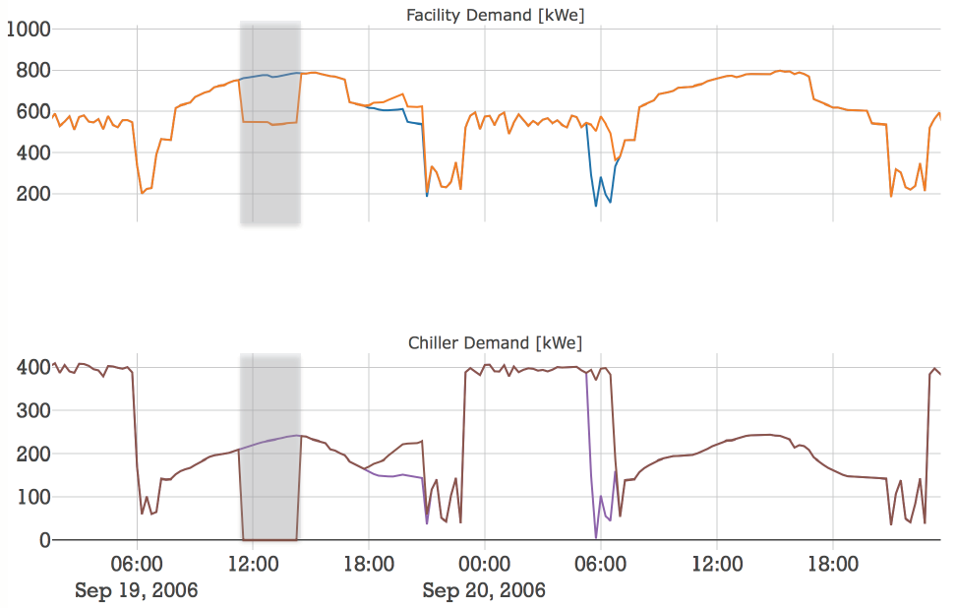

Normal Operation

Demand Response

Normal Operation

Demand Response

Figure 1: Examining the impacts of a 3-hour, no-notice demand response event (shaded region) applied to an existing Partial Storage control strategy. The delayed rebound effects in facility electrical demand and chiller electrical demand are observed at the end of the day and during the ice recharge period.

1. References

“AHSRAE Handbook: 2016 HVAC Systems and Equipment,” Atlanta, GA: ASHRAE, 2016.

"EnergyPlus V.9.1.0," ed: U.S. Department of Energy, 2019.

J. Glazer, "ASHRAE Design Guide for Cool Thermal Storage," RP-1719, Atlanta, GA: ASHRAE: 2019.

"OpenStudio 2.8.0," ed: U.S. Department of Energy, 2019.